

software design and architecture

Lab Report # 10



Topic: Design Pattern

**Question 1:**

Draw abstract factory pattern

**Diagram:**

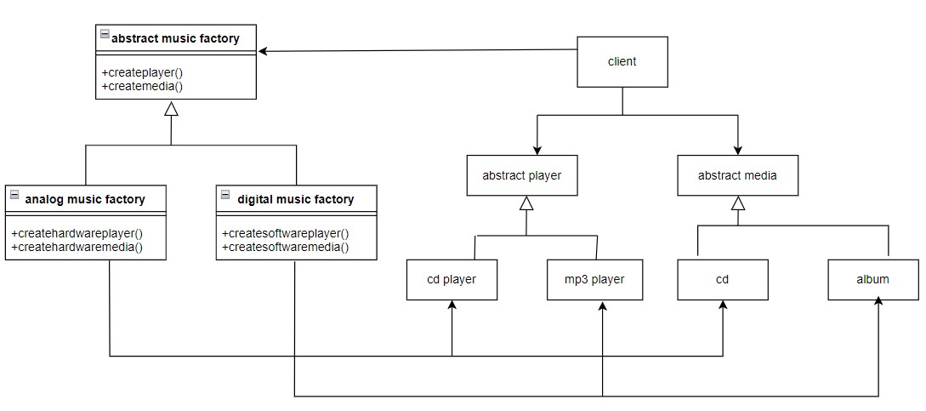

**Question 2:**

Draw pattern which you think java programming language has

**Diagram:**

* We used decorator creational pattern;

